**WT ASSIGNMENT**

DONE BY AYUSH DAS 012

**Question 1) Create a simple HTML page using basic tags**

**INPUT-**

<html>

<head>

<title> Student Information </title>

</head>

<body>

<h4> Basic Tags</h4>

</body>

</html>

**OUTPUT-** 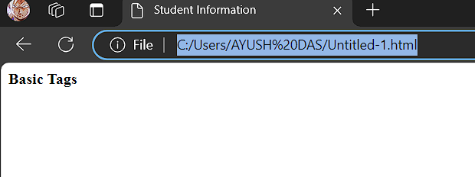

**Question 2) Create a web page that displays your name to the screen.**

**INPUT-**

<html>

<head>

<title> Student Information </title>

</head>

<body style="background-color:powderblue;">

<h2 style="background-color:Tomato;"> Student Name - AYUSH DAS </h2>

</body>

</html>

**OUTPUT-**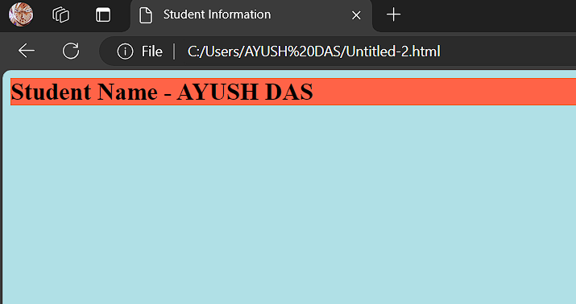

**Question 3) Create a web page and show the output from 1 to 10 in separate lines**

**INPUT-**

<html>

<head>

<title> Student Information </title>

</head>

<body style="background-color:powderblue;">

<h4 style="background-color:Tomato;"> Student Name - AYUSH DAS </h4>

<p> 1 </p>

<p> 2 </p>

<p> 3 </p>

<p> 4 </p>

<p> 5 </p>

<p> 6 </p>

<p> 7 </p>

<p> 8 </p>

<p> 9 </p>

<p> 10 </p>

</body>

</html>

**OUTPUT -** 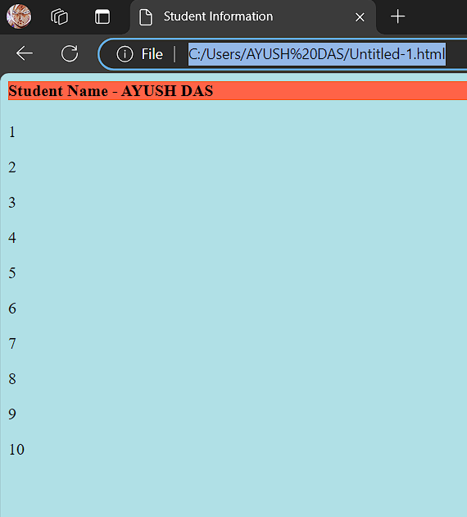

**Question 4) Create a web page and show the output from 1 to 10 in separate lines, each number being in different color.**

**INPUT-**

<html>

<head>

<title> Student Information </title>

</head>

<body style="background-color:powderblue;">

<h4 style="background-color:Tomato;"> Student Name - AYUSH DAS</h4>

<p style="color:red;"> 1 </p>

<p style="color:purple;"> 2 </p>

<p style="color:orange;"> 3 </p>

<p style="color:pink;"> 4 </p>

<p style="color:green;"> 5 </p>

<p style="color:blue;"> 6 </p>

<p style="color:brown;"> 7 </p>

<p style="color:yellow;"> 8 </p>

<p style="color:violet;"> 9 </p>

<p style="color:black;"> 10 </p>

</body>

</html>

**OUTPUT -**

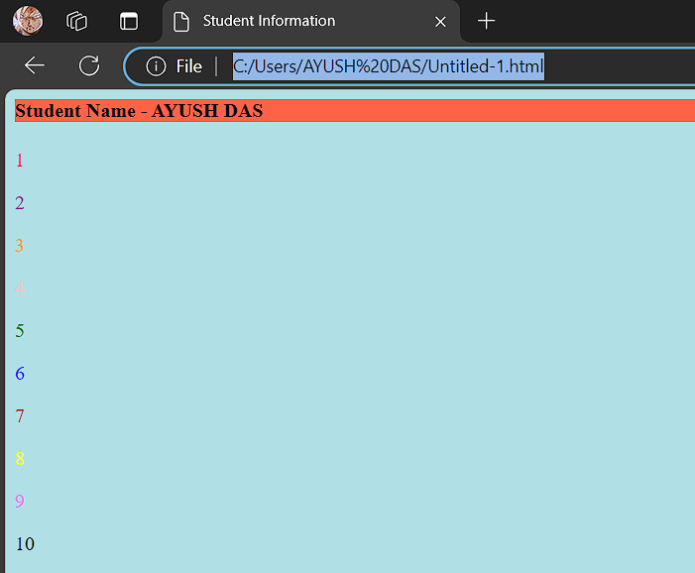

**Question 5) How do I make a picture as a background on my web pages?**

**INPUT-**

<html>

<head>

<title> Student Information </title>

</head>

<body style="background-color:powderblue;">

<h3 style="color:Tomato;"> Adding picture to background </h3>

<img src=”"C:\Users\AYUSH DAS\Downloads\2421050.webp"” >

</body>

</html>

**OUTPUT -** 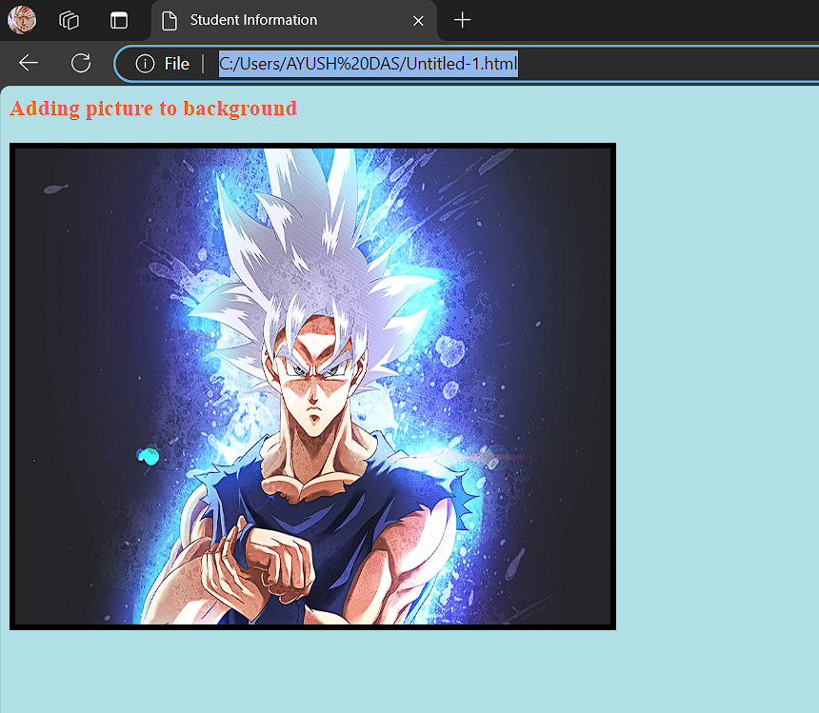

**Question 6) Create a web page to print a paragraph with 4-5 sentences, each sentence shall have a different font**

**INPUT-**

<html>

<head>

<title> Student Information </title>

</head>

<body style="background-color:powderblue;">

<h5 style="Font-Family:Cursive;"> This is Paragraph one </h5>

<h4 style="Font-Family:Fantasy;"> This is Paragraph two </h4>

<h3 style="Font-Family:Helvetica;"> This is Paragraph three </h3>

<h2 style="Font-Family:Courier New;"> This is Paragraph four </h2>

<h1 style="Font-Family:Verdana New;"> This is Paragraph five</h1>

</body>

</html>

**OUTPUT -** 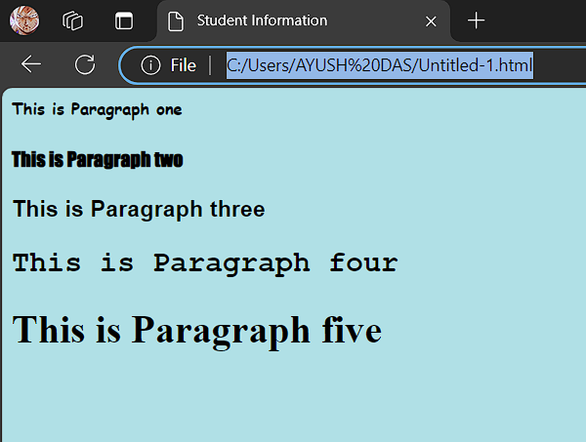

**Question 7) Write HTML code to print a paragraph that is description of a book, it shall include the title of the book, its author name; name and title should be underlined and all adjectives shall be bold and Italics.**

**INPUT-**

<html>

<head>

<title> Student Information </title>

</head>

<body style="background-color:powderblue;">

<p>Book name - <b><u><i>Dragon Ball Super, Vol. 4</b></u></i> Author name - <b><u><i>By [Akira Toriyama](https://www.simonandschuster.ca/authors/Akira-Toriyama/29540077),Illustrated by [Toyotarou](https://www.simonandschuster.ca/authors/Toyotarou/173550723)</b></u></i></p>

</body>

</html>

**OUTPUT -** 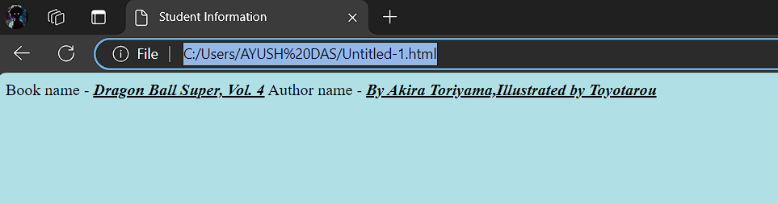

**Question 8) Write HTML code to print your name using Heading tag, every letter shall be of different heading size**

**INPUT-**

<html>

<head>

<title> Heading Tag </title>

</head>

<body style="background-color:powderblue;">

<h1>A</h1>

<h2>Y</h2>

<h3>U</h3>

<h4>S</h4>

<h5>H</h5>

</body>

</html>

**OUTPUT -** 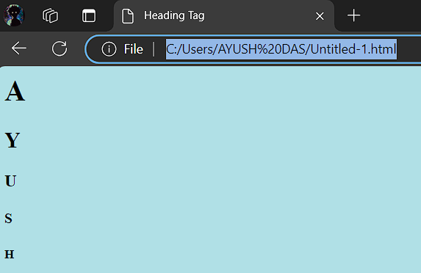

**Question 9) Write HTML code to print the sequence of numbers 1-20. Each number shall be in different line with number 2 next to it as subscript, an equal sign and the result.**

**INPUT-**

<html>

<head>

<title> Heading Tag </title>

</head>

<body style="background-color:powderblue;">

<p>1<sub>2</sub> = 2</p>

<p>2<sub>2</sub> = 4</p>

<p>3<sub>2</sub> = 6</p>

<p>4<sub>2</sub> = 8</p>

<p>5<sub>2</sub> = 10</p>

<p>6<sub>2</sub> = 12</p>

<p>7<sub>2</sub> = 14</p>

<p>8<sub>2</sub> = 16</p>

<p>9<sub>2</sub> = 18</p>

<p>10<sub>2</sub> = 20</p>

<p>11<sub>2</sub> = 22</p>

<p>12<sub>2</sub> = 24</p>

<p>13<sub>2</sub> = 26</p>

<p>14<sub>2</sub> = 28</p>

<p>15<sub>2</sub> = 30</p>

</body>

</html>

**OUTPUT -** 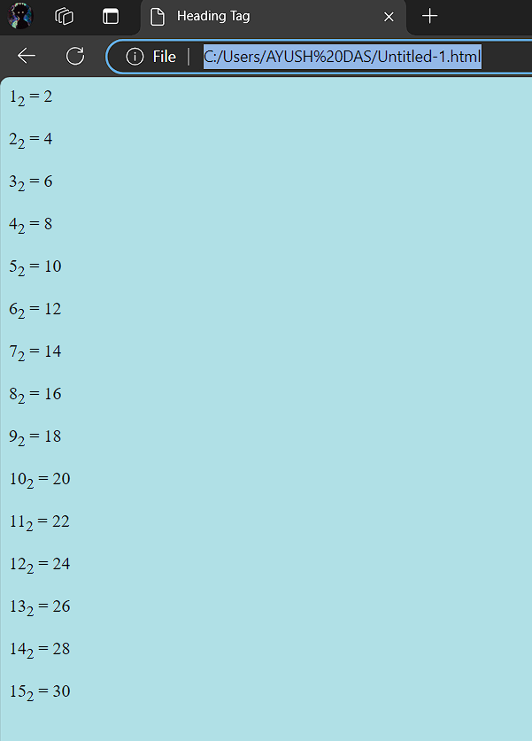

**Question 10) Write HTML code to display an image with border of size with width 200, height 200 pixels, leaving Hspace and Vspace of your choice with image hanging in the right side on the screen**

**INPUT-**

<html>

<head>

<title>Image Example</title>

</head>

<body>

<img src=""C:\Users\AYUSH DAS\Downloads\4478f6b3ac497b92d464cf3004057722.jpg"" width="400" height="300" style="border: 5px solid black;" align="right">

</body>

</html>

**OUTPUT-** 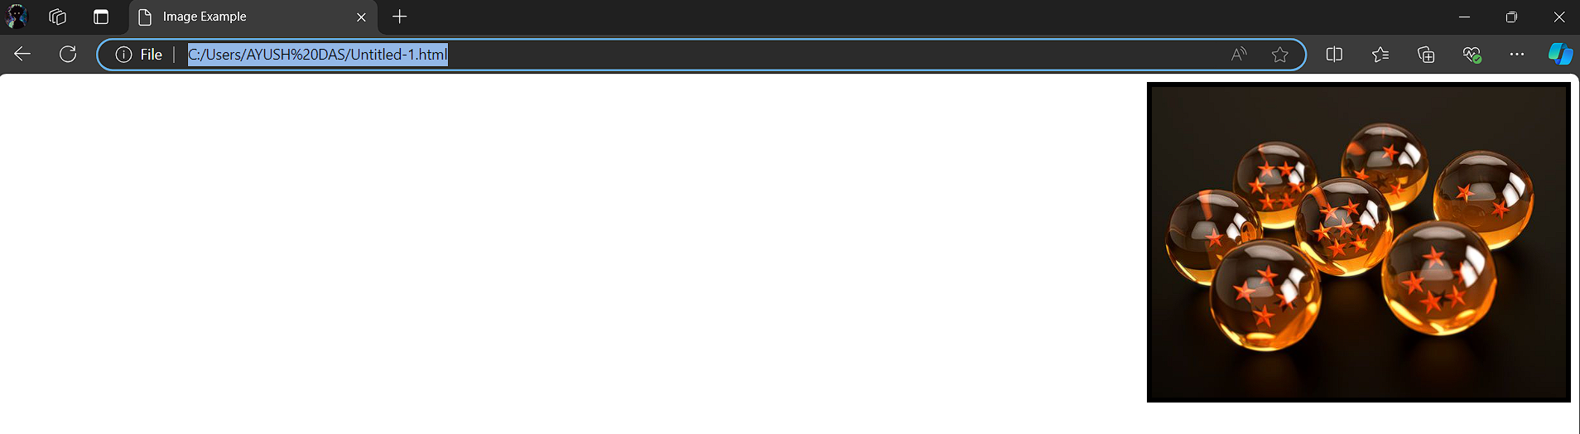

**Question 11) write a html code to create a web page with heading. the heading shall be displayed at the top-centre of the page and the image shall be at the centre , just below the heading .**

**INPUT-**<html>

<head>

<title>Web Page with Centered Heading and Image</title>

</head>

<body>

<h1 style="text-align: center;">Heading</h1>

<div style="text-align: center;">

<img src="C:\Users\AYUSH DAS\Downloads\dragon-ball-super-ultra-instinct-goku-by-toyotaro-1122898.jpeg"width="200" height="200" alt="Centered Image">

</div>

</body>

</html>

**OUTPUT -** 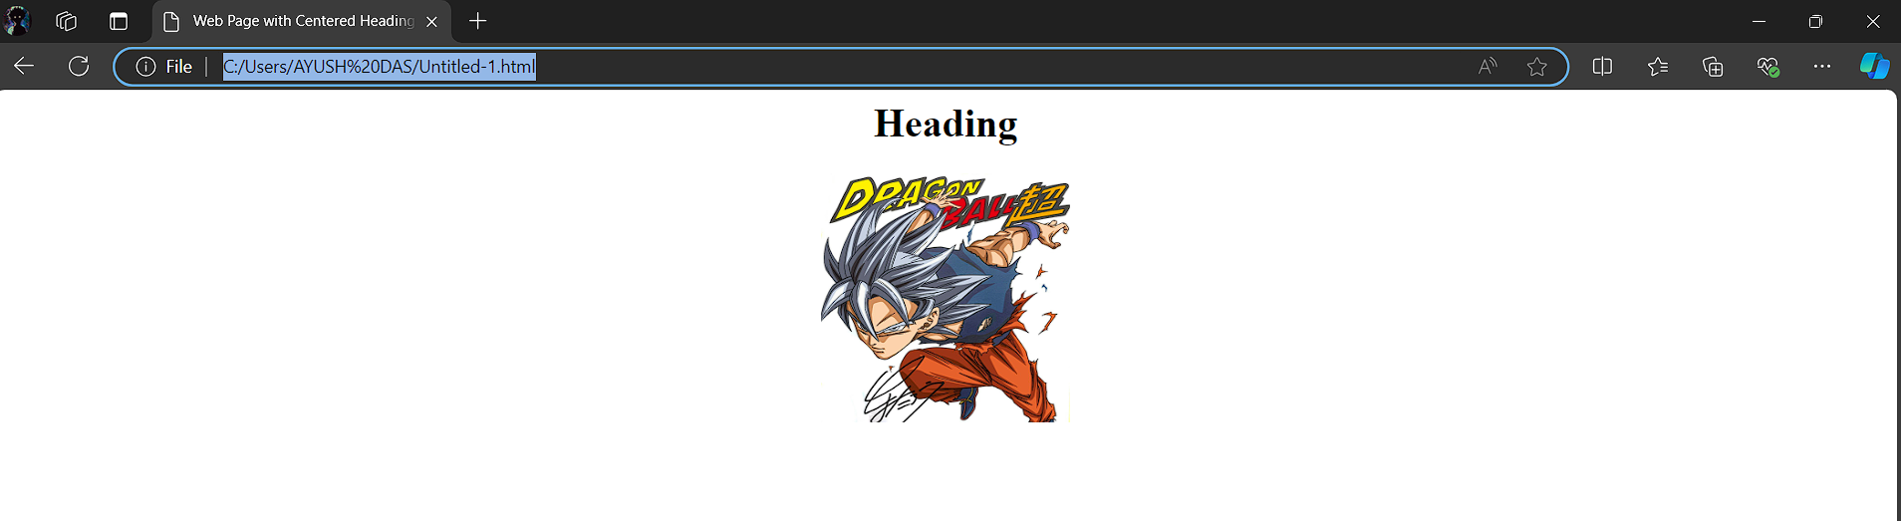

**Question 12) Write HTML code using Multimedia tags.**

**INPUT-**<html>

<head>

<title> multimedia tags</title>

</head>

<body>

<h1> multimedia tags: </h1>

<h1>img</h1>

<center>

<img src="C:\Users\AYUSH DAS\Downloads\b322ea642b1221d5bf04903718e9321f.jpg" alt="scenery" height="450" , width="450"/>

<h1> audio </h1>

<audio src="C:\Users\AYUSH DAS\Downloads\wowowowowowowow-103214.mp3" controls/>

</body>

</html>

**OUTPUT -** 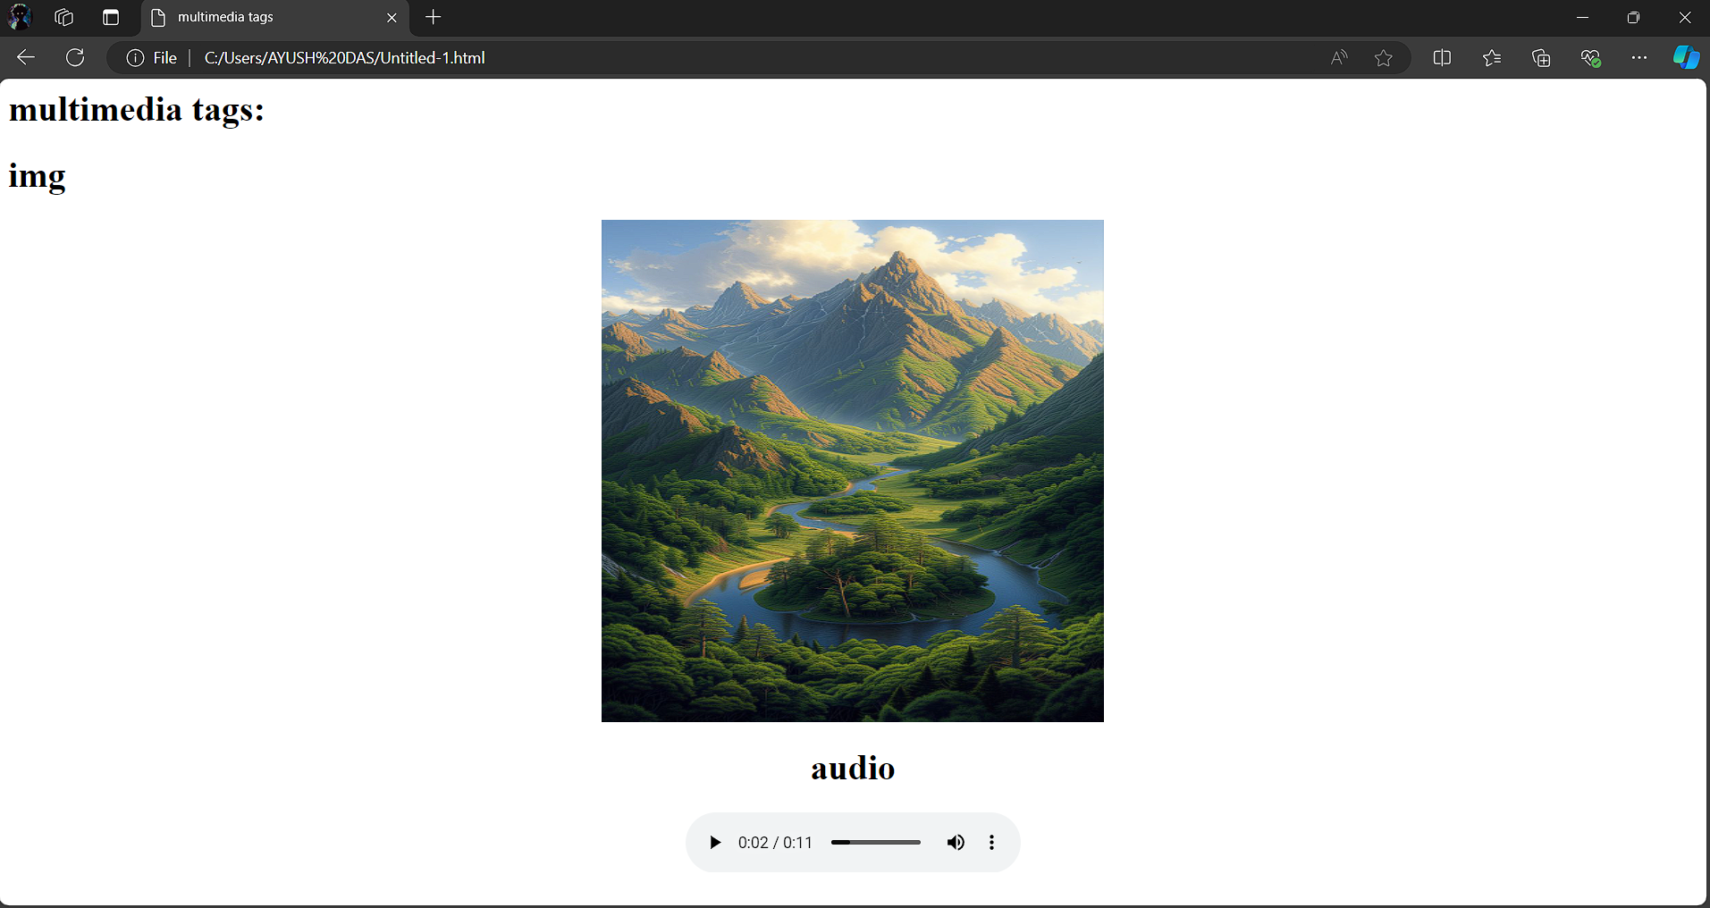

**Question 13) Create a Table using Rowspan and Colspan taking example of student Record .**

**INPUT-**<html>

<head></head>

<body>

<table border='4pt'>

<tr>

<th colspan='2'>Name</th>

<th>class</th>

<th>school</th></tr>

<tr>

<td rowspan='2'>ARJUN</td>

<td rowspan='2'>KUMAR</td>

<td> 11</td>

<td>mvps</td></tr>

<tr>

<td>A</td></tr>

<tr>

<td rowspan='2'>ARUN</td>

<td rowspan='2'>SINGH</td>

<td> 3</td>

<td>nvps</td></tr>

<tr>

<td>B</td></tr>

</body>

</html>

**OUTPUT-**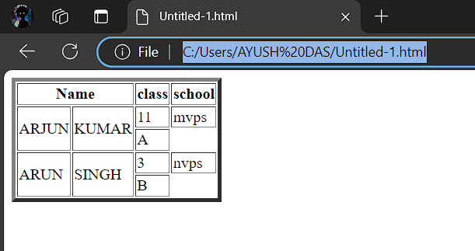

**Question 14) Write HTML code using table tag <table> and cellpadding and cell spacing as its attributes.**

**INPUT-**<html>

<head></head>

<body>

<table border="2pt" cellspacing="5pt" cellpadding="5pt">

<tr>

<th>S.no</th>

<th>Roll no.</th>

<th>Name</th>

<th>Address</th></tr>

<tr>

<td>1</td>

<td>123</td>

<td>ABC</td>

<td>FBD</td></tr>

<tr>

<td>2</td>

<td>456</td>

<td>XYZ</td>

<td>delhi</td></tr>

<tr>

<td>3</td>

<td>789</td>

<td>PQR</td>

<td>gurgaon</td></tr>

</table></body>

</html>

**OUTPUT -** 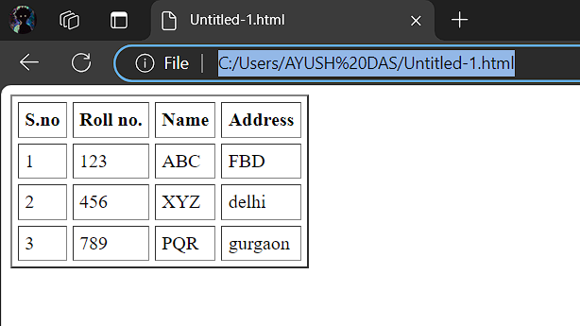

**Question 15) Create unordered, ordered and definition Lists taking example of your subjects in MCA IST, IInd and IIIrd Semester.**

**INPUT-  
<**html>

<head>

</head>

<body>

<h2> Subjects in BCA sem 1</h3>

<ol>

<li>Web technologies</li>

<li>Introduction to IT & programming in C</li>

<li>Mathematics</li>

<li>DBMS</li>

<li>SDGs</li>

<li>IKS</li>

<li>CDCs</li>

</ol>

<h2> Sunject in BCA sem 2 </h2>

<ul>

<li>COMMUNICATION</li>

<li>DATA STRUCTURE</li>

<li>JAVA</li>

<li>OPERATING SYSTEM</li>

<li>STATICS FOR BCA</li>

</ul>

<h2>Subjects in BCA Sem 3</h2>

<dl>

<dt>C++</dt>

<dt>COMPUTER ARCHITECTURE</dt>

<dt>BUSINESS ECONOMICS</dt>

<dt>ELEMENT OF STATICS</dt>

<dt>DSA OF C++</dt>

</dl>

</body>

</html>

**OUTPUT -** 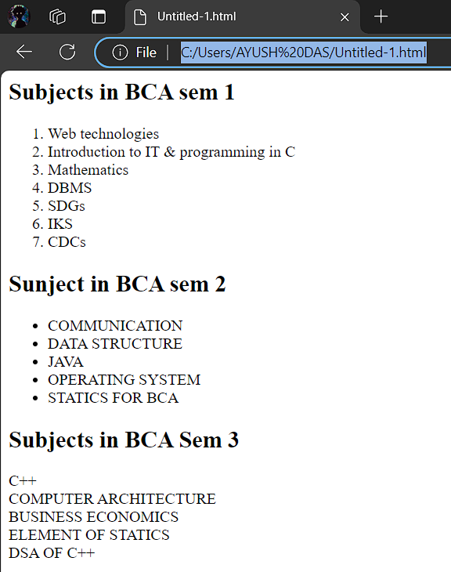

**Question 16) Write HTML code using <frameset> and <frame> tag with all its attributes .**

**INPUT-**<html>

<head>

<title>Frameset Example</title>

</head>

<frameset rows="50%,50%" frameborder="1" bordercolor="black" framespacing="5">

<frame src="https://www.example.com" name="topFrame" scrolling="yes" noresize="noresize" target="_self" />

<frame src="https://www.example.org" name="bottomFrame" scrolling="auto" noresize="noresize" target="_self" />

</frameset>

<noframes>

<body>

<p>Your browser does not support frames. Please update your browser.</p>

</body>

</noframes>

</html>

**OUTPUT -** 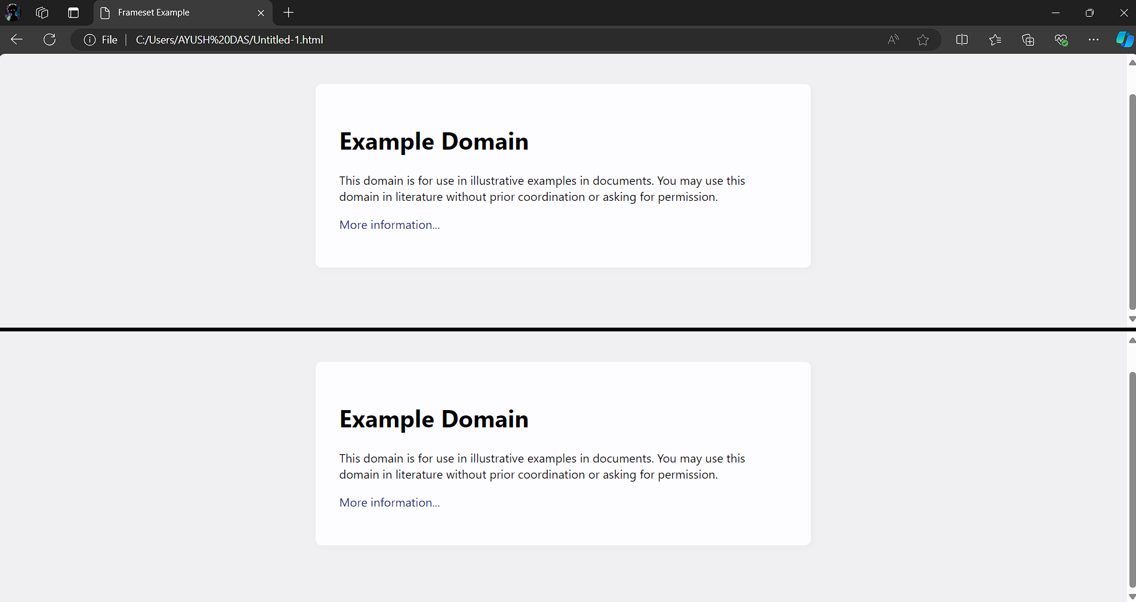

**Question 17 Write HTML code to design a form in HTML using controls and buttons such as Teaxtbox, Textarea, password, submit button, browse button, drop-down menu**

**INPUT-**<html>

<head>

<title>Form with Various Controls</title>

</head>

<body>

<h1>Registration Form</h1>

<form action="submit.php" method="post" enctype="multipart/form-data">

<label for="name">Name:</label>

<input type="text" id="name" name="name" required><br><br>

<label for="email">Email:</label>

<input type="email" id="email" name="email" required><br><br>

<label for="password">Password:</label>

<input type="password" id="password" name="password" required><br><br>

<label for="profile_pic">Profile Picture:</label>

<input type="file" id="profile_pic" name="profile_pic"><br><br>

<label for="country">Country:</label>

<select id="country" name="country">

<option value="india">India</option>

<option value="usa">USA</option>

<option

value="uk">UK</option>

</select><br><br>

<label for="message">Message:</label>

<textarea id="message" name="message" rows="5" cols="30"></textarea><br><br>

<input type="submit" value="Submit">

<input type="reset" value="Reset">

</form>

</body>

</html>

**OUTPUT -** 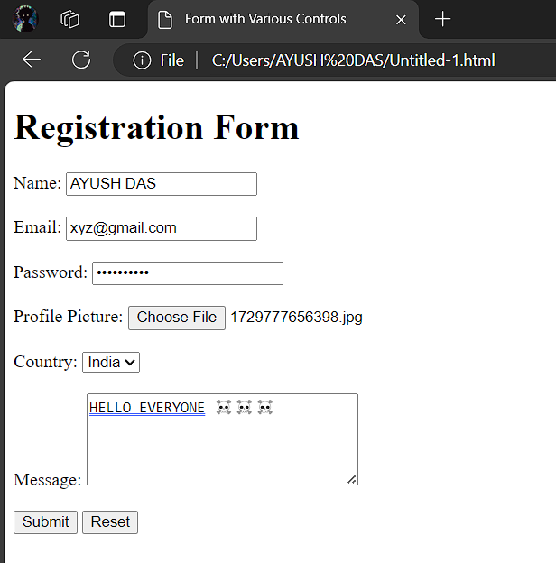

**Question 18. Write HTML code to design a Registration Form in HTML.**

**INPUT-**

<html>

<head>

<title>Grade Volleyball Registration Form</title>

</head>

<body>

<h1>Grade Volleyball Registration Form</h1>

<form action="submit.php" method="post">

<label for="first_name">Participant Name</label><br>

<input type="text" id="first_name" name="first_name" placeholder="First"><br>

<input type="text" name="last_name" placeholder="Last"><br><br>

<label for="age">Age</label><br>

<input type="number" id="age" name="age"><br><br>

<label for="grade">Grade</label><br>

<select id="grade" name="grade">

<option value="">Please select</option>

<option value="1">1</option>

<option value="2">2</option>

</select><br><br>

<label for="school_district">School District</label><br>

<input type="text" id="school_district" name="school_district"><br><br>

<label for="shirt_size">Shirt Size</label><br>

<select id="shirt_size" name="shirt_size">

<option value="">Please select</option>

<option value="s">Small</option>

<option value="m">Medium</option>

<option value="l">Large</option>

<option value="xl">Extra Large</option>

</select><br><br>

<label for="parent_first_name">Parent Name</label><br>

<input type="text" id="parent_first_name" name="parent_first_name" placeholder="First"><br>

<input type="text" name="parent_last_name" placeholder="Last"><br><br>

<label for="emergency_contact">Emergency Contact</label><br>

<input type="text" id="emergency_contact" name="emergency_contact"><br><br>

<input type="submit" value="Submit">

</form>

</body>

</html>

**OUTPUT -** 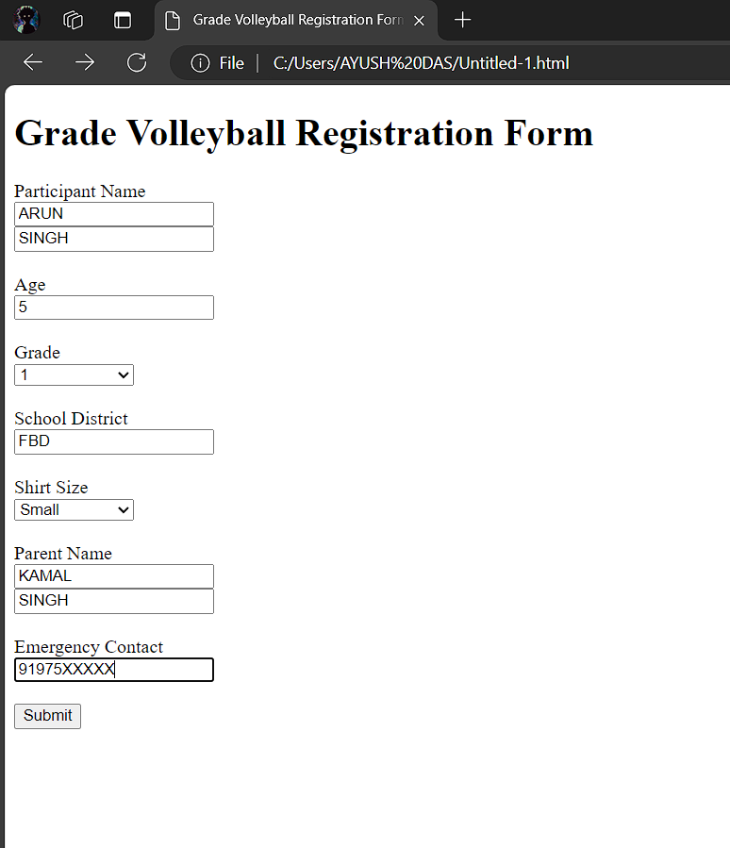

**Question 19) Write HTML code to design a student admission Form in HTML.**

**INPUT-**

<html>

<head>

<title>Student Admission Form</title>

</head>

<body>

<h1>Student Admission Form</h1>

<form action="submit.php" method="post">

<label for="student_name">Student Name</label><br>

<input type="text" id="student_name" name="student_name" required><br><br>

<label for="date_of_birth">Date of Birth</label><br>

<input type="date" id="date_of_birth" name="date_of_birth" required><br><br>

<label

for="gender">Gender</label><br>

<input type="radio" id="male" name="gender" value="male">

<label for="male">Male</label>

<input type="radio" id="female"

name="gender" value="female">

<label for="female">Female</label><br><br>

<label for="address">Address</label><br>

<textarea id="address" name="address"

rows="5" cols="30" required></textarea><br><br>

<label for="phone_number">Phone Number</label><br>

<input type="tel" id="phone_number" name="phone_number" required><br><br>

<label for="email">Email</label><br>

<input type="email" id="email" name="email" required><br><br>

<label for="class">Class</label><br>

<select id="class" name="class" required>

<option value="">Please select</option>

<option value="1">1</option>

<option value="2">2</option>

</select><br><br>

<label for="guardian_name">Guardian Name</label><br>

<input type="text" id="guardian_name" name="guardian_name" required><br><br>

<label for="guardian_contact">Guardian Contact</label><br>

<input type="tel" id="guardian_contact" name="guardian_contact" required><br><br>

<input type="submit" value="Submit">

</form>

</body>

</html>

**OUTPUT -** 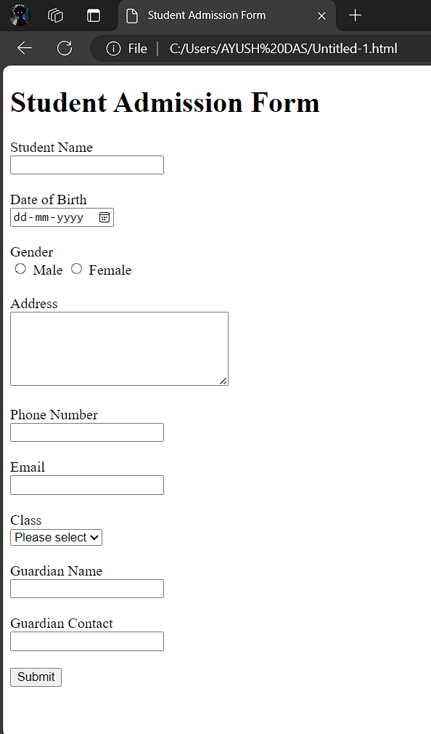

**Question 20) Create a proper home page of your own using any components and styles.**

**INPUT-**

<html>

<head>

<title>My Personal Website</title>

<link rel="stylesheet" href="styles.css">

</head>

<body>

<header>

<h1>My Name</h1>

<nav>

<ul>

<li><a href="index.html">Home</a></li>

<li><a href="about.html">About</a></li>

<li><a href="projects.html">Projects</a></li>

<li><a href="contact.html">Contact</a></li>

</ul>

</nav>

</header>

<main>

<section>

<h2>Welcome to My

Website!</h2>

<p>This is a brief introduction about myself. Feel free to explore my projects and contact me.</p>

<img src="C:\Users\AYUSH DAS\Downloads\vfkm7qjadg051.jpg" alt="Profile Picture">

</section>

</main>

<footer>

<p>&copy; 2023 My Name</p>

</footer>

</body>

</html>

**OUTPUT-**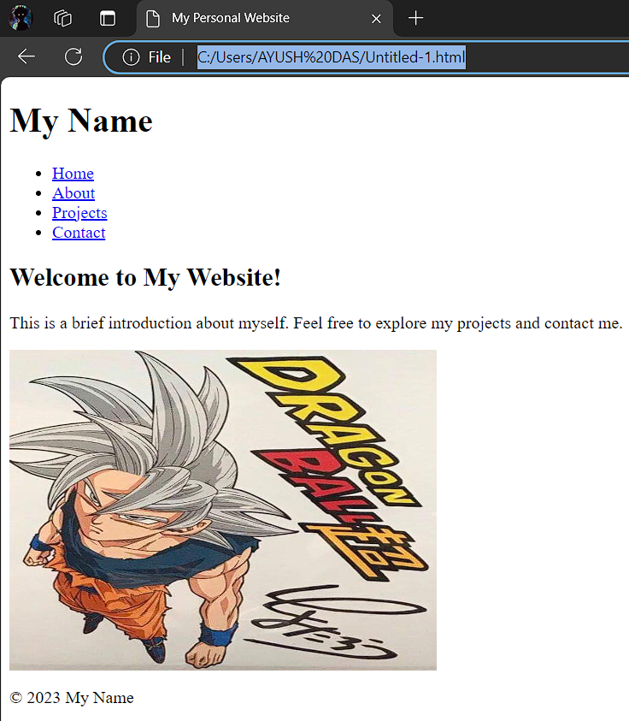

**Question 21) Write HTML code for including Local hyperlinking in a web page.**

**INPUT-**

<html>

<head>

<meta charset="UTF-8">

<meta name="viewport" content="width=device-width, initial-scale=1.0">

<title>Local Hyperlinking Example</title>

</head>

<body>

<h1>Welcome to My Web Page</h1>

<p>Click the links below to jump to different sections of the page:</p>

<ul>

<li><a href="#section1">Go to Section 1</a></li>

<li><a href="#section2">Go to Section 2</a></li>

<li><a href="#section3">Go to Section 3</a></li>

</ul>

<div id="section1">

<h2>Section 1</h2>

<p>This is the first section of the page.</p>

</div>

<div id="section2">

<h2>Section 2</h2>

<p>This is the second section of the page.</p>

</div>

<div id="section3">

<h2>Section 3</h2>

<p>This is the third section of the page.</p>

</div>

</body>

</html>

**OUTPUT-**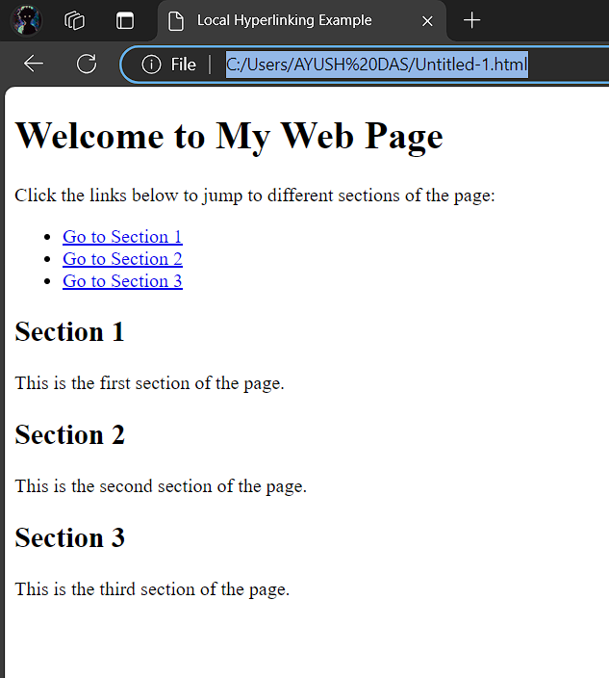

**Question 22) Write HTML code for including Inter hyperlinking in a web page.**

**INPUT-**

<html>

<head>

<meta charset="UTF-8">

<meta name="viewport" content="width=device-width, initial-scale=1.0">

<title>Link to Another Page</title>

</head>

<body>

<h1>Welcome to the Homepage</h1>

<nav>

<ul>

<li><a href="about.html">About Us</a></li>

<li><a href="services.html">Our Services</a></li>

<li><a href="contact.html">Contact Us</a></li>

</ul>

</nav>

</body>

</html>

**OUTPUT-**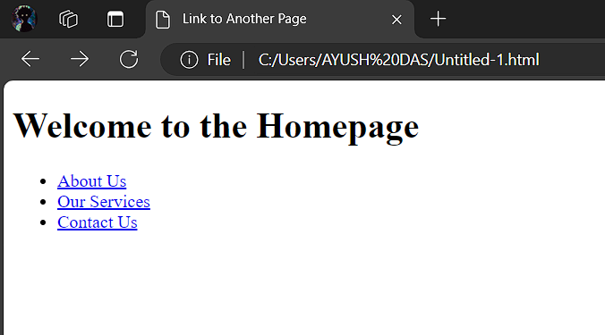

**Question 23) Write HTML code for including External hyperlinking in a web page**

**INPUT-**

<html>

<head>

<meta charset="UTF-8">

<meta name="viewport" content="width=device-width, initial-scale=1.0">

<title>External Link Example</title>

</head>

<body>

<h1>Welcome to My Web Page</h1>

<p>Click the link below to visit an external website:</p>

<a href="https://www.example.com" target="_blank">Visit Example.com</a>

</body>

</html>

**OUTPUT-**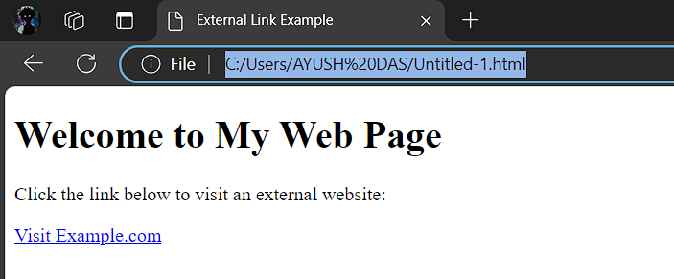

**Question 24) Write code to show External CSS with HTML code**

**INPUT-**

<html>

<head>

<meta charset="UTF-8">

<meta name="viewport" content="width=device-width, initial-scale=1.0">

<title>External CSS Example</title>

<link rel="stylesheet" href="styles.css">

</head>

<body>

<h1>Hello, World!</h1>

<p>This is an example of an HTML document styled with external CSS.</p>

<button>Click Me!</button>

</body>

</html>

**OUTPUT-**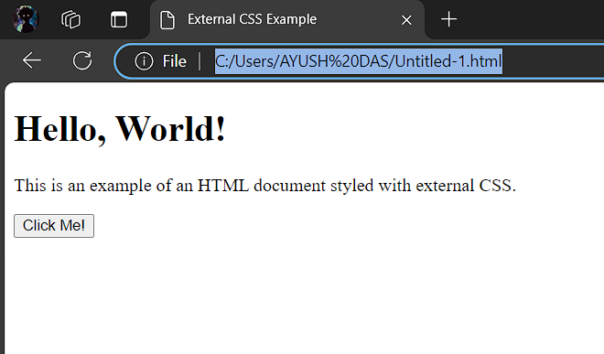

**Question 25) Write code to show Internal CSS with HTML code.**

**INPUT-**

<html>

<head>

<meta charset="UTF-8">

<meta name="viewport" content="width=device-width, initial-scale=1.0">

<title>Internal CSS Example</title>

<style>

body {

font-family: Arial, sans-serif;

background-color: #f4f4f9;

margin: 0;

padding: 0;

}

h1 {

color: #333;

text-align: center;

margin-top: 20px;

}

p {

color: #555;

font-size: 18px;

text-align: center;

line-height: 1.6;

}

.highlight {

background-color: yellow;

font-weight: bold;

}

.container {

width: 80%;

margin: 0 auto;

padding: 20px;

background-color: #fff;

border-radius: 8px;

box-shadow: 0 0 10px rgba(0, 0, 0, 0.1);

}

</style>

</head>

<body>

<div class="container">

<h1>Welcome to My Website</h1>

<p>This is an example of an HTML document with internal CSS.</p>

<p class="highlight">This text is highlighted using a CSS class.</p>

</div>

</body>

</html>

**OUTPUT-**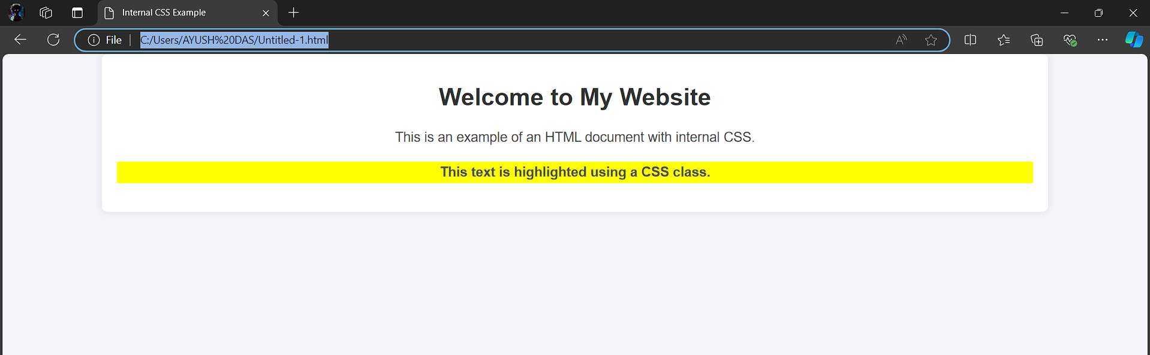

**Question 26) Write code to show Inline CSS with HTML code**

**INPUT-**

<html>

<head>

<meta charset="UTF-8">

<meta name="viewport" content="width=device-width, initial-scale=1.0">

<title>Inline CSS Example</title>

</head>

<body>

<h1 style="color: blue; text-align: center;">Welcome to My Web Page</h1>

<p style="font-size: 18px; color: green; font-family: Arial, sans-serif;">This is a simple paragraph with inline CSS styling. You can apply styles directly within HTML tags using the "style" attribute.</p>

<div style="background-color: lightgray; padding: 10px; border-radius: 5px;">

<p style="color: darkred;">This div has a light gray background, rounded corners, and some padding.</p>

</div>

<button style="background-color: #4CAF50; color: white; padding: 10px 20px; border: none; border-radius: 5px; cursor: pointer;">

Click Me

</button>

</body>

</html>

**OUTPUT-** 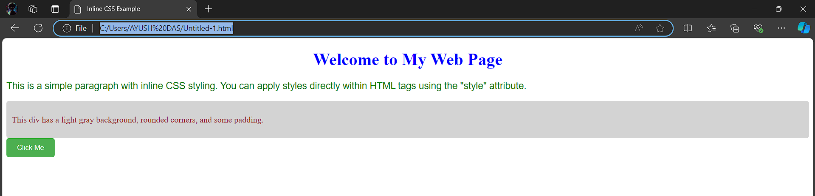

**Question 27) Write a program to add two numbers using form in JavaScript.**

**INPUT-**

<html>

<head>

<meta charset="UTF-8">

<meta name="viewport" content="width=device-width, initial-scale=1.0">

<title>Add Two Numbers</title>

<script>

function addNumbers() {

const num1 = parseFloat(document.getElementById("num1").value);

const num2 = parseFloat(document.getElementById("num2").value);

if (isNaN(num1) || isNaN(num2)) {

document.getElementById("result").innerHTML = "Please enter valid numbers.";

} else {

const sum = num1 + num2;

document.getElementById("result").innerHTML = "Result: " + sum;

}

}

</script>

</head>

<body>

<h2>Add Two Numbers</h2>

<form onsubmit="event.preventDefault(); addNumbers();">

<label for="num1">Number 1: </label>

<input type="number" id="num1" required>

<br><br>

<label for="num2">Number 2: </label>

<input type="number" id="num2" required>

<br><br>

<input type="submit" value="Add">

</form>

<p id="result"></p>

</body>

</html>

**OUTPUT-**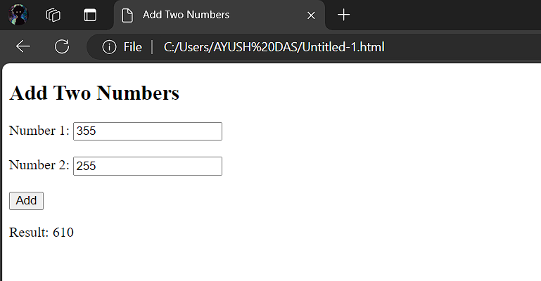

**Question 28) Write a program in JavaScript to swap two images using on mouseover event.**

**INPUT-**

<html>

<head>

<meta charset="UTF-8">

<meta name="viewport" content="width=device-width, initial-scale=1.0">

<title>Swap Images on Mouseover</title>

</head>

<body>

<img id="image1" src="Downloads/OIP (1).jpeg" alt="Image 1" width="500" height="500" onmouseover="swapImages()" onmouseout="resetImages()">

<img id="image2" src="Downloads/OIP.jpeg" alt="Image 2" width="500" height="500" onmouseover="swapImages()" onmouseout="resetImages()">

<script>

function swapImages() {

var image1 = document.getElementById("image1");

var image2 = document.getElementById("image2");

var tempSrc = image1.src;

image1.src = image2.src;

image2.src = tempSrc;

}

function resetImages() {

var image1 = document.getElementById("image1");

var image2 = document.getElementById("image2");

image1.src ="Downloads/OIP (1).jpeg";

image2.src ="Downloads/OIP.jpeg" ;

}

</script>

</body>

</html>

**OUTPUT-**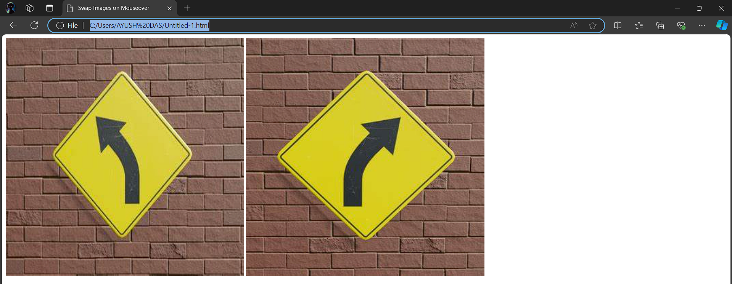

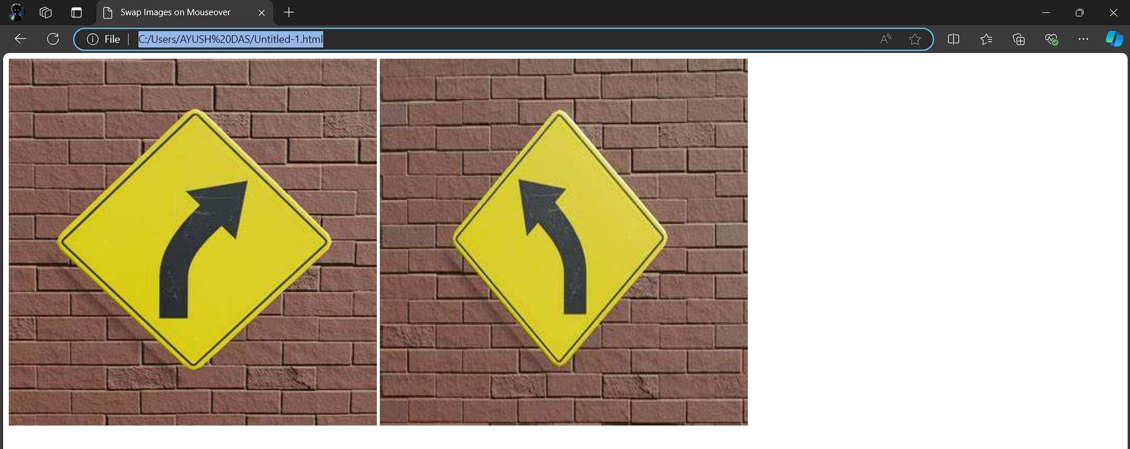

**Question 29) Write a simple JavaScript program to sort an array**

**INPUT-**

let numbers = [5, 3, 8, 1, 2, 7,99,88,543,12,667,7879];

numbers.sort(function(a, b) {

return a - b;

});

console.log("Sorted array:", numbers);

**OUTPUT-**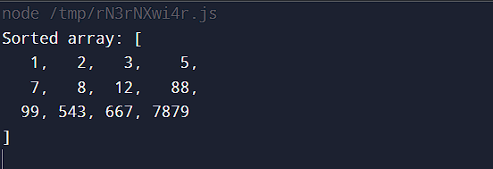

**Question 30) Write a JavaScript program to take as input three numbers from the user. Find the minimum and maximum of the three numbers. Print the following output in BOLD in the following format: MINIMUM = MAXIMUM =**

**INPUT-**

<html>

<head>

<meta charset="UTF-8">

<meta name="viewport" content="width=device-width, initial-scale=1.0">

<title>Find Minimum and Maximum</title>

</head>

<body>

<h2>Find Minimum and Maximum of Three Numbers</h2>

<label for="num1">Enter first number:</label>

<input type="number" id="num1" required>

<br><br>

<label for="num2">Enter second number:</label>

<input type="number" id="num2" required>

<br><br>

<label for="num3">Enter third number:</label>

<input type="number" id="num3" required>

<br><br>

<button onclick="findMinMax()">Find Minimum and Maximum</button>

<h3 id="output"></h3>

<script>

function findMinMax() {

const num1 = parseFloat(document.getElementById("num1").value);

const num2 = parseFloat(document.getElementById("num2").value);

const num3 = parseFloat(document.getElementById("num3").value);

if (isNaN(num1) || isNaN(num2) || isNaN(num3)) {

alert("Please enter valid numbers in all fields.");

return;

}

const minimum = Math.min(num1, num2, num3);

const maximum = Math.max(num1, num2, num3);

document.getElementById("output").innerHTML = `

<strong>MINIMUM = ${minimum}</strong> &nbsp;&nbsp;&nbsp;&nbsp;

<strong>MAXIMUM = ${maximum}</strong>

`;

}

</script>

</body>

</html>

**OUTPUT-** 